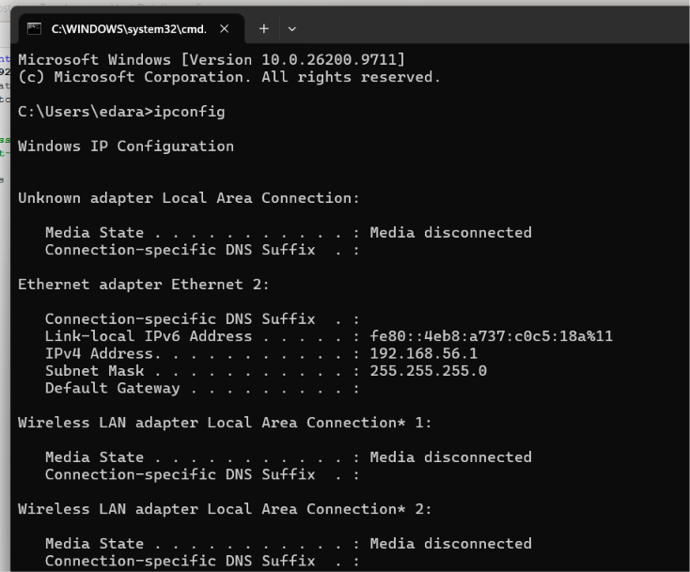
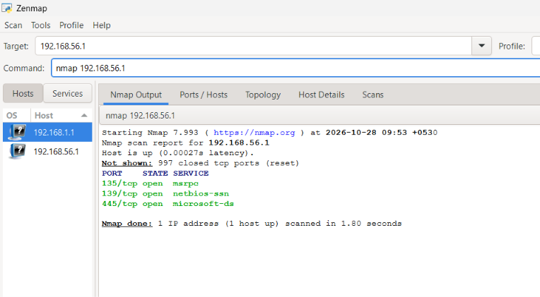
- nmap 192.168.56.1 Scan common ports
- nmap -sn 192.168.56.1 Discover live hosts
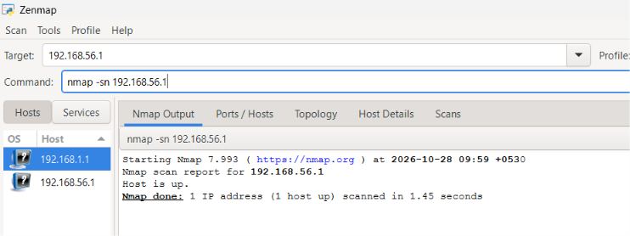
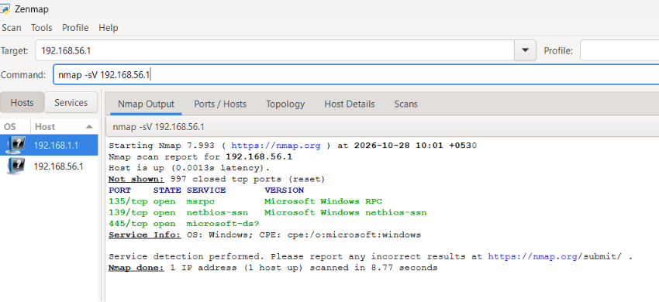
- nmap -sV 192.168.56.1 Detect service versions

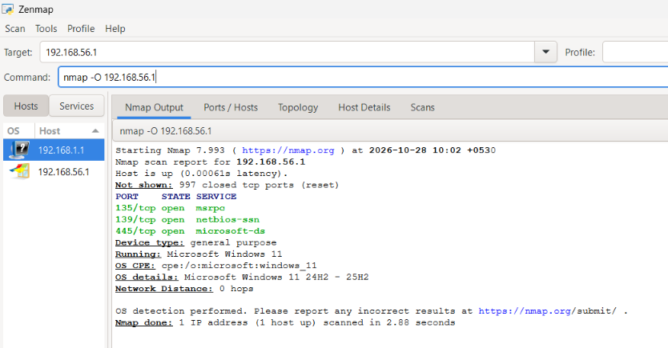
- nmap -O 192.168.56.1 Identify the operating system

- nmap -p 80,443 192.168.56.1 Scan specific ports
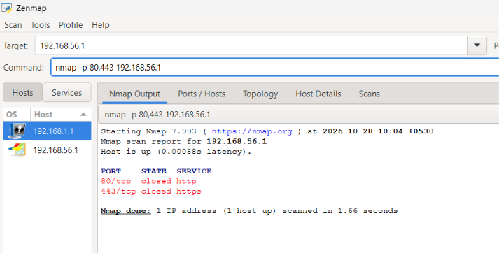
- nmap -sC 192.168.56.1 Run default NSE scripts
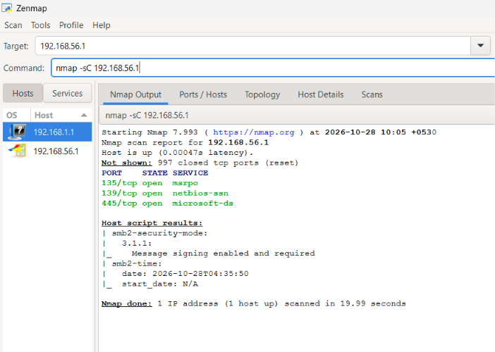
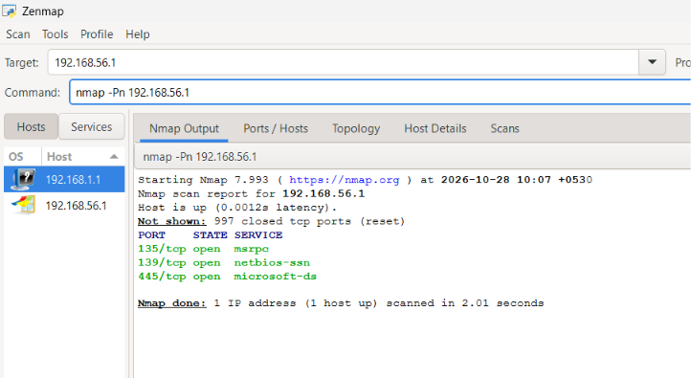
- nmap -Pn 192.168.56.1 Skip host discovery

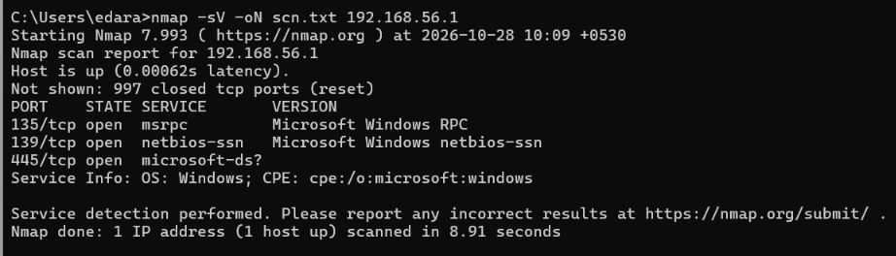
- nmap -oN scan.txt 192.168.56.1 Save scan results to a file

